**Name – Shaurya Singh Srinet**

**Reg No – RA2111032010006**

**Branch –CSE w/s in IoT**

**Section – T2**

**Object Oriented Design and Programming**

**Assignment: Week 12: -**

1. Write a C++ program to create a file.  
Code: -

#include <bits/stdc++.h>

using namespace std;

int main()

{

   fstream file;

   file.open("Gfg.txt",ios::out);

   if(!file)

   {

       cout<<"Error in creating file!!!";

       return 0;

   }

   cout<<"File created successfully.";

   file.close();

   return 0;

}

Input and Output: -

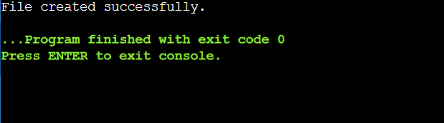

2. Write a C++ program to read a text file.  
Code: -

#include <iostream>

#include <fstream>

using namespace std;

int main() {

fstream Gfg;

Gfg.open("Gfg.txt", ios::in);

if (!Gfg) {

cout << "No such file";

}

else {

char ch;

while (1) {

Gfg >> ch;

if (Gfg.eof())

break;

cout << ch;

}

}

Gfg.close();

return 0;

}

Text File:  
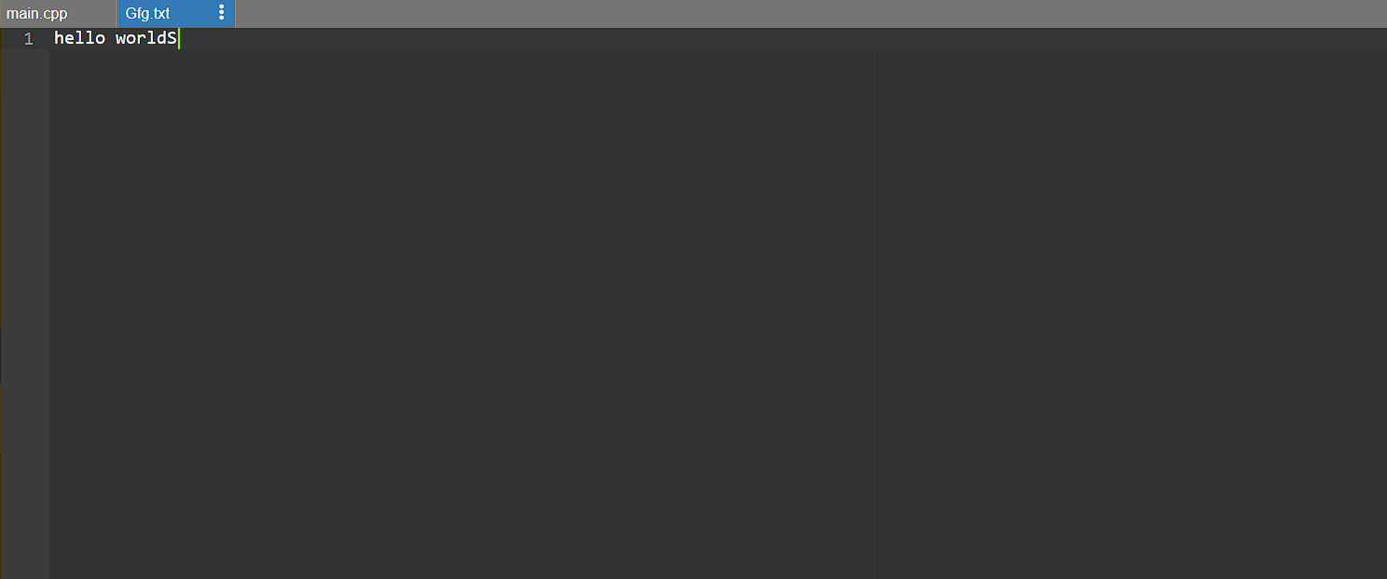  
Input and Output: -

3. Write a C++ program to write and read text in /from file.  
Code: -

#include <iostream>

#include <fstream>

using namespace std;

int main()

{

fstream file;

file.open("sample.txt",ios::out);

if(!file)

{

cout<<"Error in creating file!!!"<<endl;

return 0;

}

cout<<"File created successfully."<<endl;

file<<"ABCD.";

file.close();

file.open("sample.txt",ios::in);

if(!file)

{

cout<<"Error in opening file!!!"<<endl;

return 0;

}

char ch;

cout<<"File content: ";

while(!file.eof())

{

file>>ch;

cout<<ch;

}

file.close();

return 0;

}  
Input and Output: -

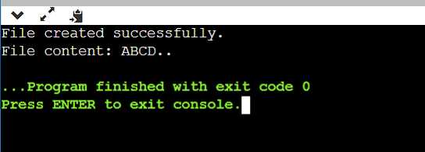

4. Write a C++ program to write and read object using read and write function.

Code: -

#include <iostream>

#include <fstream>

using namespace std;

class student

{

private:

char name[30];

int age;

public:

void getData(void)

{ cout<<"Enter name:"; cin.getline(name,30);

cout<<"Enter age:"; cin>>age;

}

void showData(void)

{

cout<<"Name:"<<name<<",Age:"<<age<<endl;

}

};

int main()

{

student s;

ofstream file;

file.open("aaa.txt",ios::out);

if(!file)

{

cout<<"Error in creating file.."<<endl;

return 0;

}

cout<<"\nFile created successfully."<<endl;

s.getData();

file.write((char*)&s,sizeof(s));

file.close();

cout<<"\nFile saved and closed succesfully."<<endl;

ifstream file1;

file1.open("aaa.txt",ios::in);

if(!file1){

cout<<"Error in opening file..";

return 0;

}

file1.read((char*)&s,sizeof(s));

s.showData();

file1.close();

return 0;

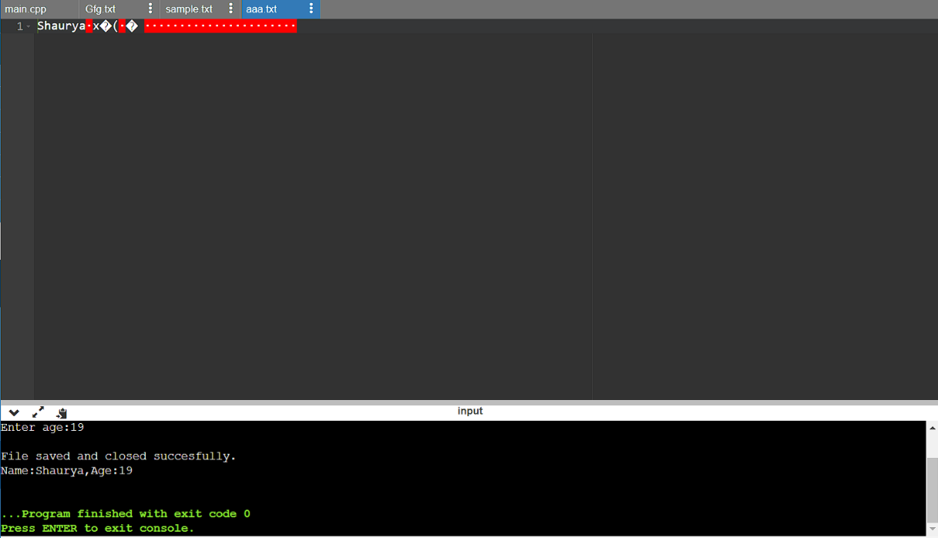}  
Input and Output: -

6. Write a C++ program to demonstrate example of tellg() and tellp() function.

Code: -

#include <iostream>

#include <fstream>

using namespace std;

int main()

{

fstream file;

file.open("sample.txt",ios::out);

if(!file)

{

cout<<"Error in creating file!!!";

return 0;

}

file<<"ABCDEFGHIJKLMNOPQRSTUVWXYZ";

cout<<"Current position is: "<<file.tellp()<<endl;

file.close();

file.open("sample.txt",ios::in);

if(!file)

{

cout<<"Error in opening file!!!";

return 0;

}

cout<<"After opening file position is: "<<file.tellg()<<endl;

char ch;

while(!file.eof())

{

cout<<"At position : "<<file.tellg();

file>>ch;

cout<<" Character \""<<ch<<"\""<<endl;

}

file.close();

return 0;

}  
  
Input and Output: -

